Massage SOAP Note
One note per session. Write it the same day.
Client name | Date | Service and length
Therapist and credentials | Practice | Pressure  ☐ Light ☐ Medium ☐ Firm ☐ Deep
Reason for visit | Pain before (0 to 10)  /10 | Pain after (0 to 10)  /10
S Subjective what the client reports  O Objective what you observed and found | Body chart mark where you found something  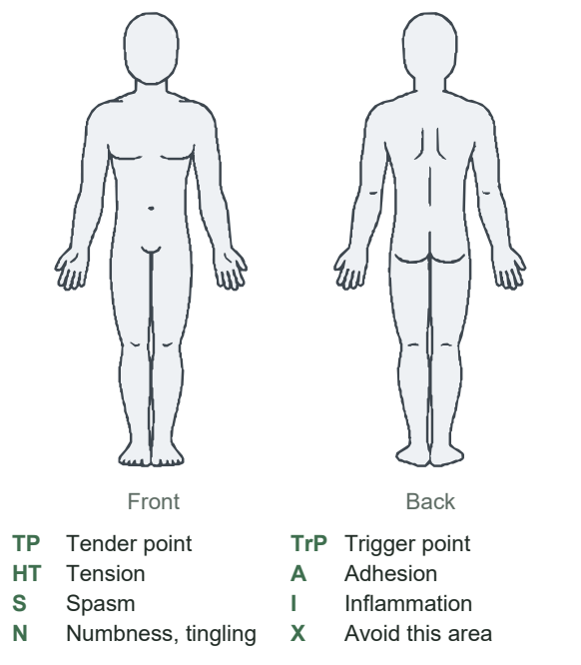
Treatment techniques, areas, pressure, time
A Assessment how the client responded and progress. No diagnosis.
P Plan next session, self-care, follow-up or referral

Therapist signature | Date signed
Corrections never erase. Add a dated correction here and initial it.

